WORKFLOW EXAMPLE 1:
Notes:
- Pharmacy timelines between 8am-5pm M-F not weekends, we can confirm with pharmacy.
- JHS Nurses certain shifts of availability- when study team needs their assistance. Please inform weekdays and hours, if possible.
- The workflow can also be color coded i.e blue for JHS and orange for UM or just differentiate one institution from the other.
-Location is key.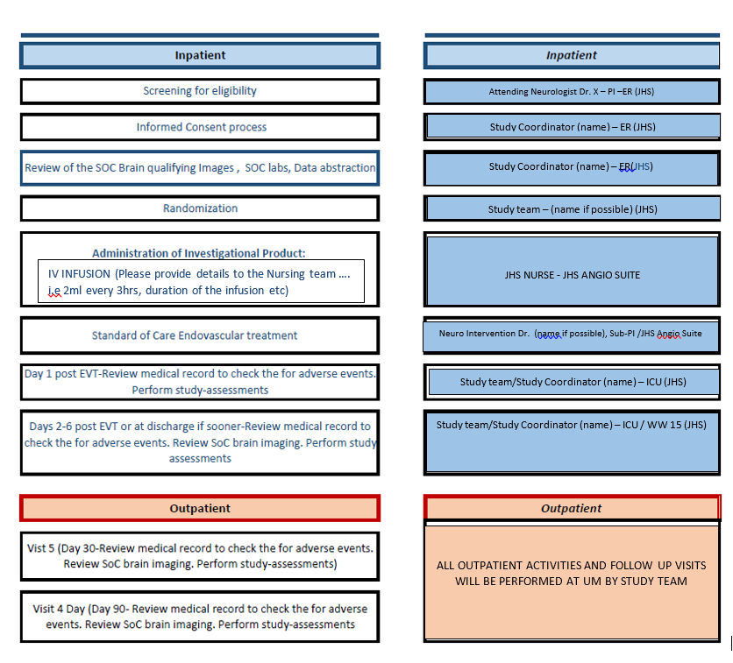

WORKFLOW EXAMPLE 2:
