Submitting New External IRB Studies in eProst IRB 8.2.4

All NEW External IRB studies must be submitted as MultiSite Studies in IRB8.2.4
- Access eProst
- Create a study
Basic Study Information Page – to capture study-wide information (documents uploaded on this page do NOT get finalized and may not be visible on Velos D-Link)
- Questions 1-3: Under Basic Study Information, enter the Title of the Study, Short Title and a Brief Description.
- Question #4: What kind of study is this?
Select: “Multi-site or Collaborative study
- Question #5: Will an external IRB act as the IRB of record for this study?
Select: “Yes”
- Question #6: Lead principal investigator
If you know the name of the overall investigator you may enter it here, otherwise, leave this question blank.
- Questions 7: Local principal investigator

Example:
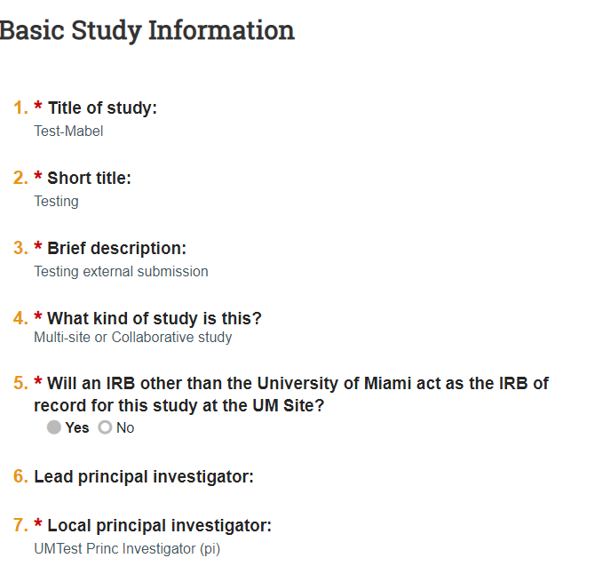
Basic Local Site Information – to capture UM General Information
- Question 1: Brief description of activities this site will perform
Describe the activities your site will perform for this study. For example, if your site will perform all study procedures, you can enter, “All study procedures.” If your site will perform only a few procedures such as analysis of identifiable data, enter “Analysis of identifiable data.”
- Question 2: Attach the protocol to be finalized – The protocol will go to Velos D-Link

Example:
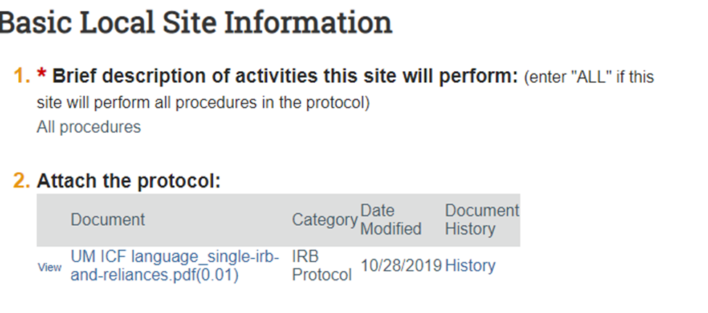
External IRB – To capture information on the Relying external IRB
- Question 1: External IRB
Select the external IRB from the drop down menu
- Question 2: External IRB ID:
If you have the external IRB’s identification number for this study, enter the number. If you do not have the number, leave the field blank.
- Question 3: Approval letter from external IRB
- Question 4: Initial approval date by external IRB
- Question 5: Last day of approval.
  - Please note that UM does not require a continuing report for external IRB studies. The study team is responsible for ensuring continuation of the reviewing IRB's approval and updating the approval date.
- Question 6: Specify the reason the study should be reviewed by an external IRB (This is required):
- Enter:
(1) Required by regulation; or
(2) Required by sponsor as a condition of conducting the trial. If neither of these answers are correct, you should not use an external IRB. Instead, the UM HSRO should review the study.

Example:
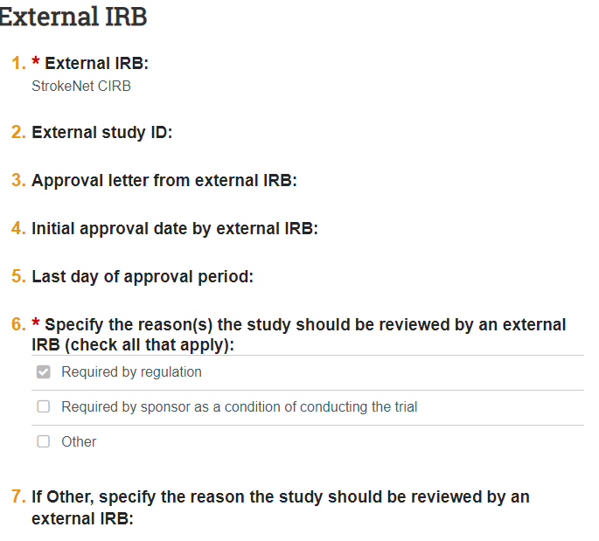
Study Funding Sources - to capture general funding source information (e.g. NIH, industry sponsor, etc.)
- Question 1: Identify each organization supplying funding for the study
- Select “+ Add” to Enter the funding sources

Example:
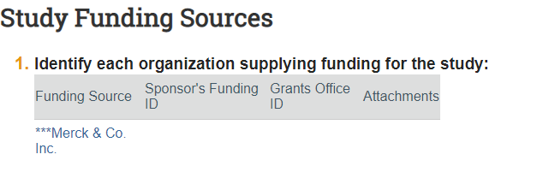
Additional Local Funding Sources – to capture UM Funding Sources, if applicable
Do not enter external funding such as NIH or sponsor funding in this section.

Example:
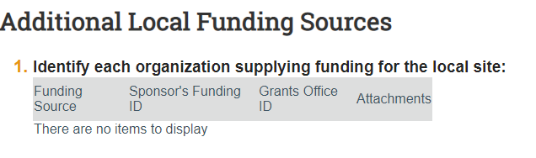
- Question 1: Identify each organization supplying funding for the local site:
- If applicable, Select “+ Add” to Enter the funding sources – You so not need to upload the grant or contract.
Local Study Team Members – To capture UM Study Team
- Question 1: Identify each additional person involved in the design, conduct or reporting of the research:
Select “+ Add” to Enter a study team member. Select the study team members from the menu. Check to see if their training is current. Training requirements are described in the Investigator Manual.
- Question 2: External team member information:
If anyone outside of the University of Miami will be working on this study under the local PI’s oversight, list them here. Do not list team members who will not be under the PI’s supervision.
- Question 3: Will any outside agency or organization conduct protocol-required research procedures. Need to answer yes or no and if yes provide an explanation & lists procedures.

Example:
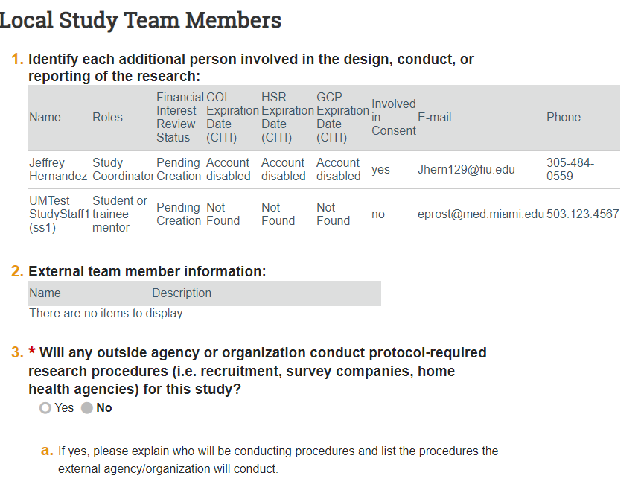
Study Scope - to capture whether the scope is Drug or Device
- Question 1: Does the study specify the use of an approved drug or biologic, use of an unapproved drug or biologic, or use a food or dietary supplement to diagnose, cure, treat, or mitigate a disease or condition?
Select either yes or no.
- Question 2: Does the study evaluate the safety or effectiveness of a device or use a humanitarian use device?
Select either yes or no.

Example:

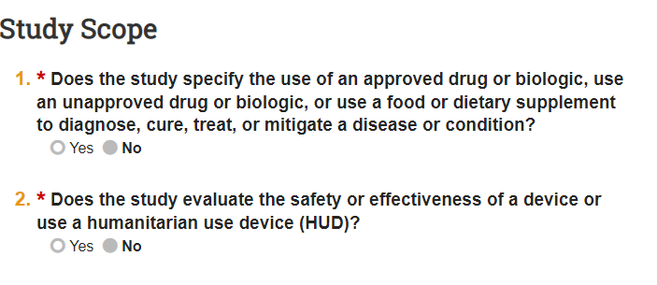
Local Research Locations
- Question 1: Identify research locations where research activities will be conducted or overseen by the local investigator:
If the local PI will be overseeing a local facility that is not part of UM or Jackson Health Systems, list the site here. Do not list other participating sites that are not under the UM PI’s oversight.
Example:
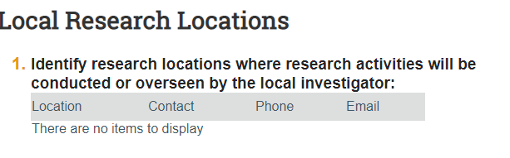
Devices or Drugs information (Depends on the scope of the study)

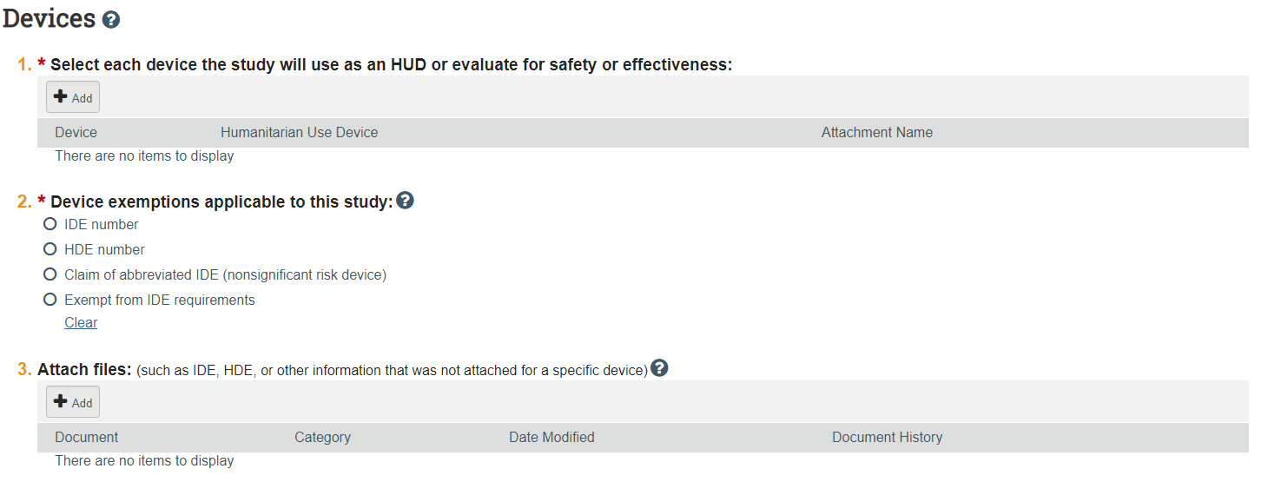

OR

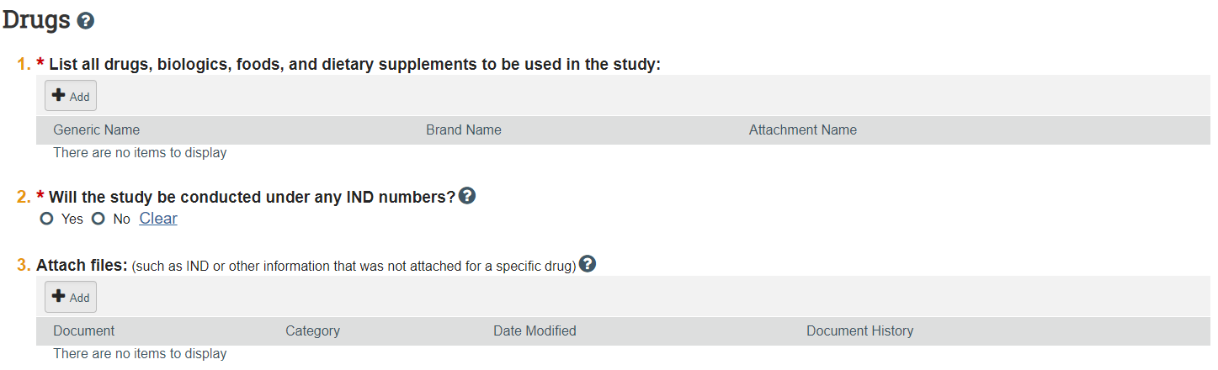

Study-Related Documents - to capture Study documents (Documents attached on this page do NOT get finalized and may not be visible on Velos D-Ling
- Questions 1-3: If the external IRB has not yet approved the study and you have study template documents, you may upload them here.
Example:
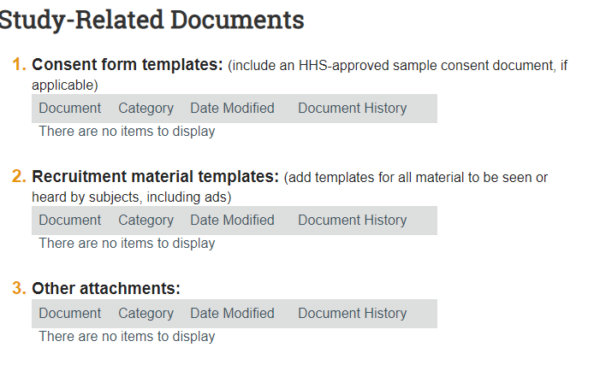
Local Site Documents
- Questions 1-3: This is where the documents approved by the external IRB should be uploaded. Upload the approval letter from the external IRB under “Other attachments.”
    - Consent Forms (to be finalized in IRB8.2.4) – This goes to Velos D-Link
    - Recruitment Materials (to be finalized in IRB8.2.4) – This goes to Velos D-Link
    - Other Attachments
      - HIPAA (to be finalized in IRB8.2.4) – This goes to Velos D-Link
      - Ancillary Review Forms
        - Biological Agents Registration Form
        - CTRS Service Request Form
        - ESCRO Form
        - IBC Supplemental Form
        - JHS CTO Application Form
        - UHT Application Form
        - Research Data Security Assessment Form
      - Genomic Data Sharing Plan
      - NIH Institutional Certification
      - Certificate of Confidentiality
      - Data Use Agreement
      - Patient Forms
        - Data Collection Sheets (to be finalized in IRB8.2.4) – This goes to Velos D-Link
        - Questionnaire/Survey/Interview/Diary
      - Other (to be finalized in IRB8.2.4) – This goes to Velos D-Link
      - HRP-216 External IRB Application to Cede Review to an External IRB
Example:
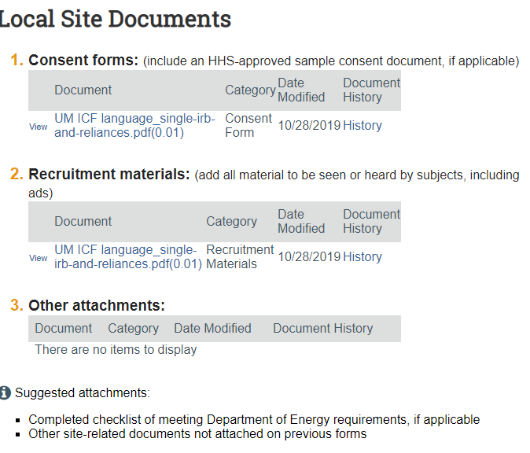

The remaining questions are the asked for all initial review submissions. Complete the submission by answering each question.

Example:
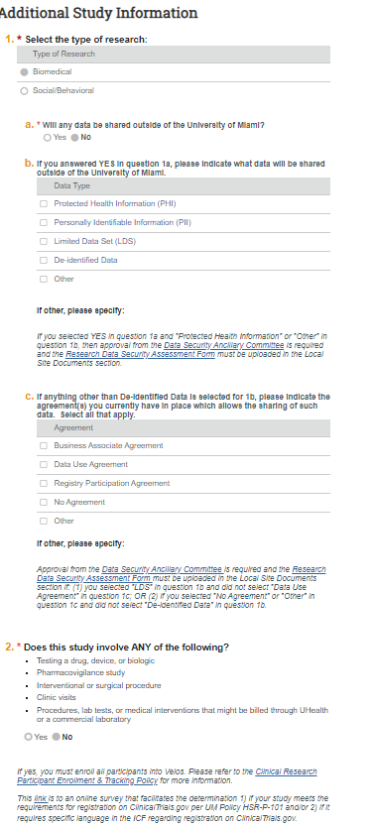
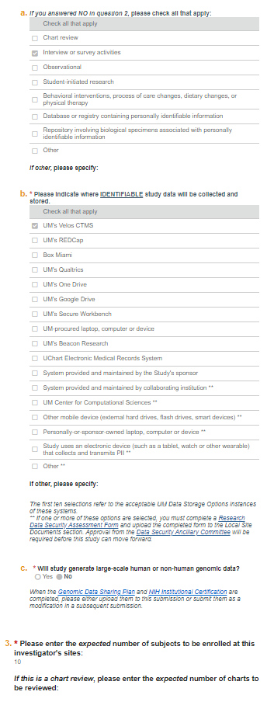
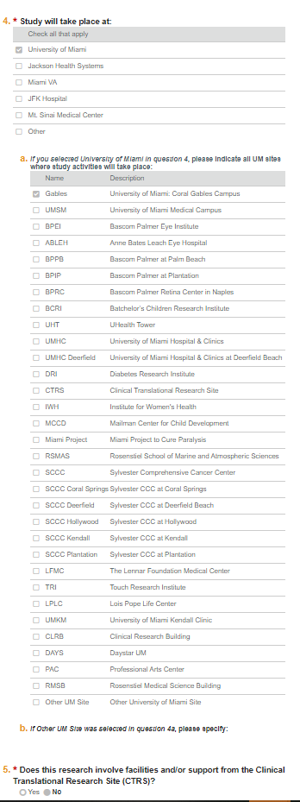
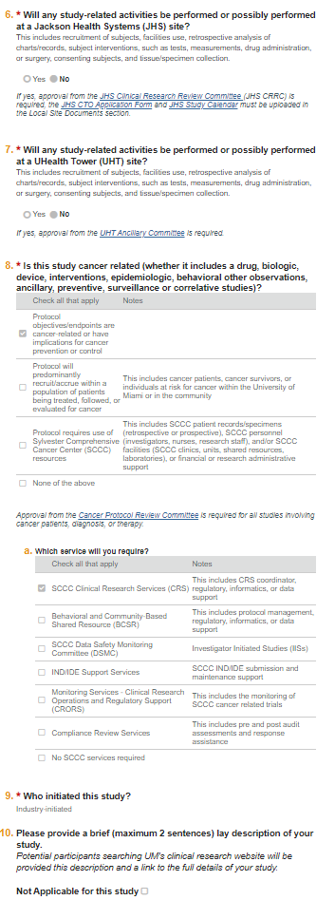
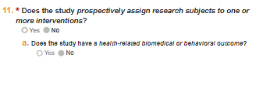
Clinical Biomedical research questions (6 questions)
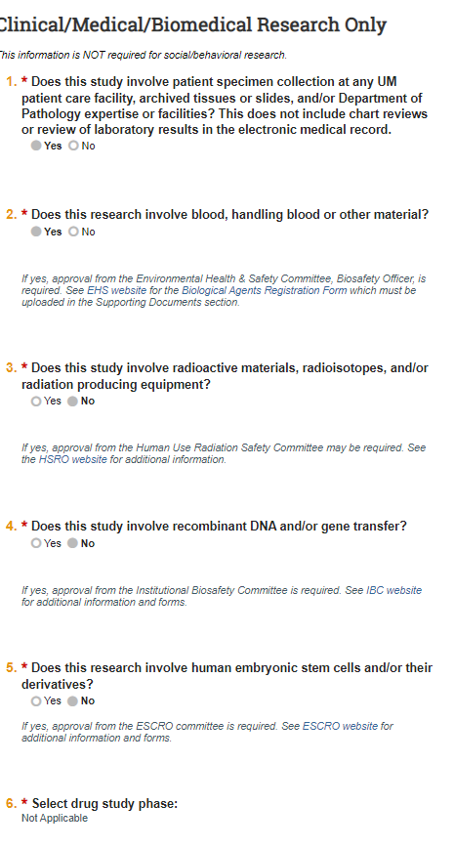

Final Page
- Click “Finish”
- Click “Submit”Could not submit (Could not execute submit due to errors. Unable, you must first fill in billing info by clicking “update billing information” activity.

Please refrain from starting the research until you receive acknowledgement from the UM HSRO

